Distinction Program – Khet

Program Description
For my distinction program, I am making a version of a board game called Khet in C#. Khet is most easily described as being laser chess. Below is an example of the board layout:
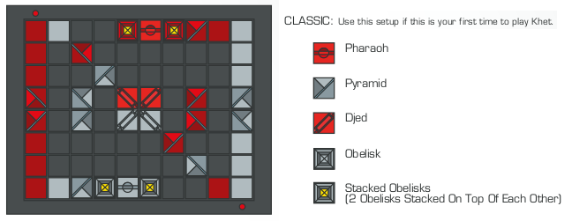
Khet has four different types of game piece, as shown above, and some of these are equipped with mirrors in order to deflect the lasers. Each player has a laser, originating from next to the red button on their side of the board.
In each turn, a player may move one of their pieces one square in any direction, or rotate one of them 90 degrees. At the end of your turn, you must press the button to fire your laser. If the laser illuminates a piece (of any player!) by hitting a non-mirrored side, that piece is killed, and so removed from the board. The aim of each game is to kill the other player's Pharaoh.
A Djed is a powerful piece that cannot be killed,as it does not have a non-mirrored side. It also has the ability to use your turn to swap places with an adjacent pyramid or obelisk.
Obelisks are shield pieces and may be stacked or unstacked as your turn. Stacks can be moved as one piece, and when one is hit with the laser, only the top Obelisk is killed.
This overview doesn't quite do it justice; the full rule booklet is here: http://bit.ly/14gDqp9

Progress
Before beginning programming, I spent a while creating a UML diagram to work out how it should be implemented. View the UML diagram on Lucidchart here: http://bit.ly/19Ilgiu
I've started the programming, and the have basic functionality of the main classes done. I realised I needed to have a board layout to test with, and so some way to load one, so I came up with a board layout file format, and created layouts for the three standard ones (see layouts.txt).

Remaining
There's a lot of work to do yet, but after my last exam on the 11th, I'll have the better part of 8 days to get it all done easily.
What's left:
- Write the rest of the model from the existing UML diagram
- Write functionality to load board layouts from file
- Plan & write gameplay functionality
- Write a laser propagation algorithm (already planned out)
- Plan the implementation of the SwinGame GUI
- Program the GUI
  - Display
  - User interaction
  - Animations, possibly

